**QR CODE GENERATOR**

Project submitted to the

**SRM University – AP**

for the partial fulfilment of the requirements to award the degree of

**Bachelor of Technology**

**In**

**Computer Science and Engineering**

(School of Engineering and Sciences)

**Submitted by**

**Vijaya Vyshnavi Muvvala AP21110010119**

**Neeli Meghana AP21110010127**



Under the Guidance of

**Prof.Kavitha Rani**

**SRM University–AP**

**Neerukonda, Mangalagiri, Guntur**

**Andhra Pradesh – 522 240**

**[Month, Year]**

2

# Certificate

Date: 12/12/2022

This is to certify that the work present in this Project entitled “**QR CODE GENERATOR**” has been carried out by **[Vijaya Vyshnavi, Neeli Meghana]** under my/our supervision. The work is genuine, original, and suitable for submission to the **SRM University – AP** for the award of Bachelor of Technology in **School of Engineering and Sciences**.

## Supervisor

(Signature)

Prof. / Dr. [Name]

Designation,

Affiliation.

## Co-supervisor

(Signature)

Prof. / Dr. [Name]

Designation,

Affiliation.

4

**Acknowledgements**

6

# Table of Contents

|  |  |
| --- | --- |
| Certificate | i |
| Acknowledgements | iii |
| Table of Contents | v |
| Abstract | vii |
| List of Publications | ix |
| Statement of Contributions | xi |
| Abbreviations | xv |
| List of Tables | xvii |
| List of Figures | xix |
| List of Equations | xxi |
| 1. Introduction | 1 |
| 1.1 Heading 2 | 1 |
| 1.1.1 Heading 3 | 1 |
| 2. Methodology | 3 |
| 2.1 Heading 2 | 3 |
| 2.1.1 Heading 3 | 3 |
| 3. Discussion | 5 |
| 4. Concluding Remarks | 7 |
| 5. Future Work | 9 |
| References | 11 |

8

# ABSTRACT

QR codes are machine readable two dimensional pixelated barcodes which can be used to store a variety of information. QR in QR code stands for Quick Response. QR code was invented by a Japanese engineer Masahiro Hara from automobile manufacturer Denso Wave in the year 1994 to track the movement of car parts.

QR codes often contain data for a locator, identifier, or [tracker](https://en.wikipedia.org/wiki/Website_visitor_tracking) that points to a website or application. QR codes use four standardized encoding modes (numeric, alphanumeric, byte/binary, and [kanji](https://en.wikipedia.org/wiki/Kanji)) to store data efficiently; extensions may also be used.



# List of Publications (Optional)

[Give the list of publications in bibliography format] Highlight (Bold) your name in the bibliography.

The thesis is mainly based on the results presented in the following articles.

1. [Author name(s)], Year. Title. Journal Name. Volume and Page Numbers. DOI Link.
2. XX
3. XX

12

# Statement of Contributions (Optional)

[Give the responsibilities and contributions of the candidate in each paper] [For example: Idea, data simulation, analysis, experimental work, and manuscript writing, etc.]

Paper I: Responsible for XXX, YYY,

Paper II:

14

# Abbreviations

16

# List of Tables

Table 1. Text for an example table…………………………..…………………………..10

18

# List of Figures

Figure 1. Text for an example figure……………………………...……………………….6

20

# List of Equations

Equation 1. Text of equation

…………………………………………………………...…15

22

23

# 1. INTRODUCTION

Good morning our respected professor and everyone who is present here! Going back to our old school days, some of the pen-paper games were always a top for our leisure time. We had designed this “HANGMAN” game and we are here to discuss about it with everyone. It might look a little elaborate but also more fun.

Hangman is a popular word guessing game where the player attempts to build a missing word by guessing one letter at a time. After a certain number of incorrect guesses, the game ends and the player lose. The game also ends if the player correctly identifies all the letters of the missing word.

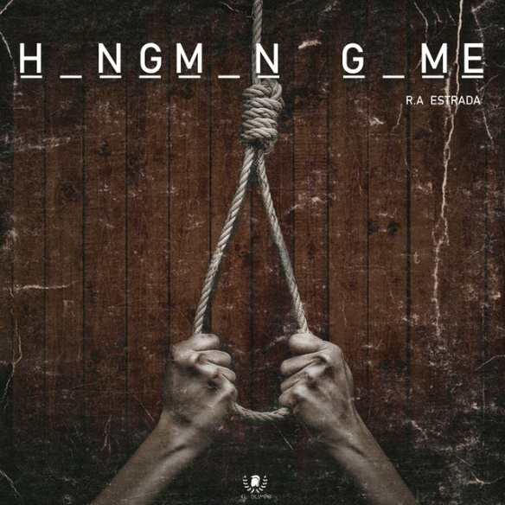

A classic way to practice the alphabet and vocabulary are by using Hangman game. Hangman game can be called as one of language game which can be used by teacher to teach the students about alphabet and vocabulary.



It means that by using Hangman game, the students can practice the alphabet and vocabulary which is really important for their English skill and it can also create fun atmosphere in teaching learning activity

25

# 2. METHODOLOGY

**BASIC HANGMAN GAME**

1)Select one person to be the “HOST”. This is the person that invents the puzzle for the other respective person to solve. They will be tasked with choosing a word or phrase that “the players” will have to solve.

2)If you are the host, choose a secret word. The other players will need to guess your word letter by letter, so choose a word you think will be difficult to guess. Difficult words usually have uncommon letters like “z” or “j”, and only a few vowels.

3)Draw a black line for each letter in the word. For example, if the host chooses the word “zipper,” she/he would draw six blanks, one for each letter (_ _ _ _ _ _ ). The host does not tell anyone else the secret word

4)Start guessing letters if you are the player. Once the word has been chosen and the players know how many letters in the secret word, begin guessing which letters are in the word by asking the host. For example, you might begin by asking the host. For example, you might begin by asking, “ is there an ‘e’ in your word?”

5)Fill the letter in the blanks if the players guess correctly. Whenever the players guess a letter that is in the secret word, the host fills in into the blank where it occurs. For example, if the word is “zipper” and the players guess “e,” then the host will fill in the 5th blank with an “e:” (_ _ _ _ e _).

6)Draw part of the “hangman” when the players guess wrong. Whenever the players guess a letter that is not in the secret word they get a strike that brings them closer to losing. To show this, the host draws a simple stick figure of a man being hung, adding a new part to the drawing with every wrong answer. This is also where you can adjust the difficulty of the game - - the more marks you make, the more wrong guesses the player gets and the easier the game is.

7)The players win when they guess the correct word. If the players get every letter of the word before the host finishes drawing then they win. At any point a player can try to guess the entire word instead of a single letter, but if they guess the wrong word then the host should treat it as if they guessed a wrong letter

**ALGORITHM:**

**Step 1: Importing Qrcode and Tkinter libraries.**

**Step 2: Making the primary window.**

**Step 3: Create a function that takes any text or URL as an input and generates a QR code.**

**Step 4: Create a User Interface for the application to Generate QR Code in Python.**

27

# 3. DISCUSSION

# Code:

Import qrcode

from tkinter import *

cp = Tk()

cp.title('copyassignment.com')

cp.geometry('700x250')

cp.config(bg='#e52165')

def generate():

img = qrcode.make(msg.get())

type(img)

img.save(f'{save_name.get()}.png')

Label(cp, text='File Saved!', bg='#e52165' , fg='black', font=('Arial Black', 8)).pack()

def show():

img = qrcode.make(msg.get())

type(img)

img.show()

frame = Frame(cp, bg='#e52165')

frame.pack(expand=True)

#------------------ENTER THE TEXT OR URL------------------

Label(frame, text='Enter the Text or URL : ', font=('Arial Black', 16),

bg='#e52165').grid(row=0, column=0, sticky='w')

msg = Entry(frame)

msg.grid(row=0, column=1)

#------------------ENTER THE FILE NAME------------------

Label(frame, text='File Name(Save As) : ', font=('Arial Black', 16),

bg='#e52165').grid(row=1, column=0, sticky='w')

save_name = Entry(frame)

save_name.grid(row=1, column=1)

#------------------BUTTONS TO SHOW OR SAVE QRCODE------------------

btn = Button(cp, text='Show QR code', bd='5', command=show, width=15)

btn.pack()

btn = Button(cp, text='Save QR code', command=generate, bd='5', width=15)

btn.pack()

cp.mainloop()

Sample Output:

1st output:

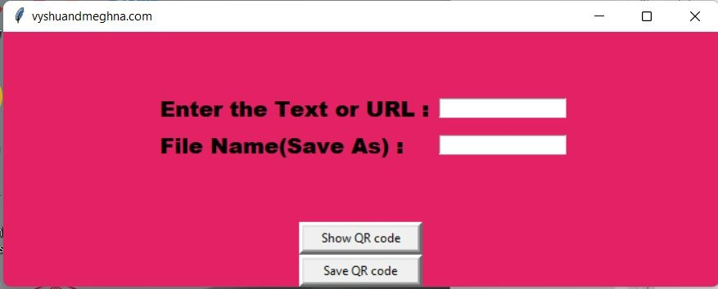

2nd output:

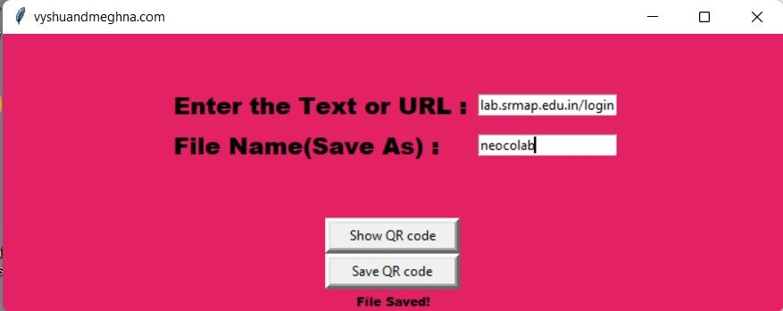

3rd output:



4th output:

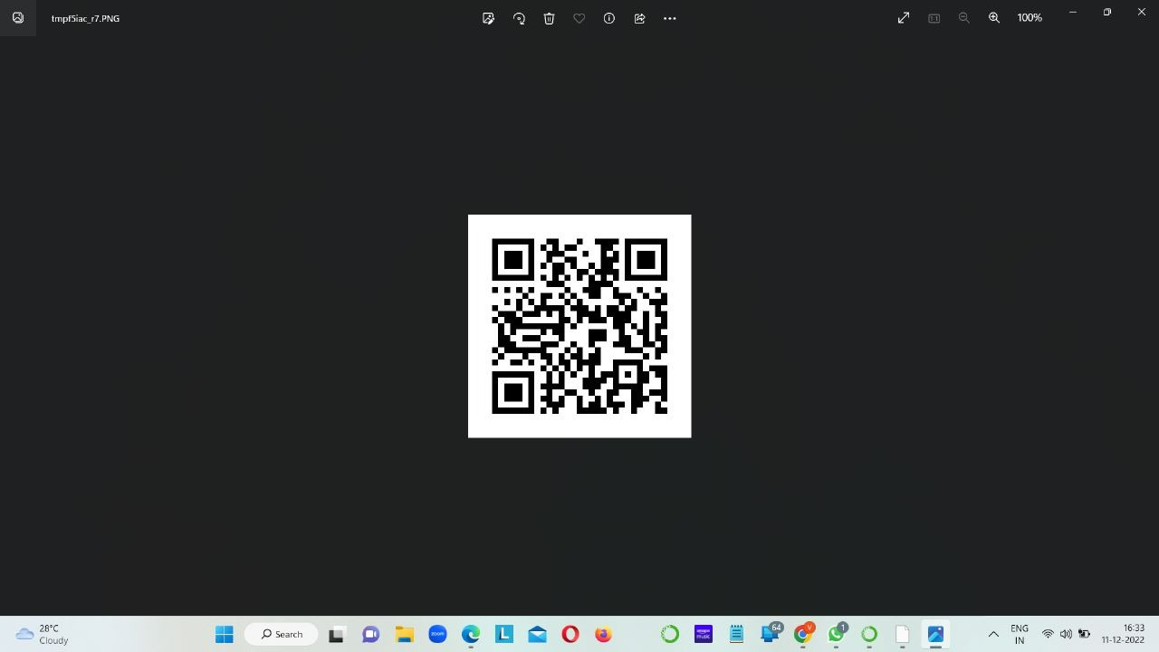

Here are the two ways for ‘The Hangman Game’.

Hangman is a word game in which the player is trying to guess a secret word. The player guesses letters, one at a time, and is told where each such letter appears in the secret word. If a guessed letter does not appear at all, it is considered a mistake. If the player makes ten mistakes in total, the game is lost.

# 4. Concluding Remarks

This is a simple Hangman game using Python programming language. We can use this as a small project to boost their programming skills and understanding logic. The Hangman program randomly selects a secret word from a list of secret words. The random module will provide this ability, so line 1 in program imports it. Hangman is a popular word game in which one player (the "chooser") chooses a secret word and another player (the "guesser") attempts to guess the word one letter at a time. If a guessed letter appears in the word, all instances of it are revealed. If not, the guesser loses a chance. If the guesser figures out the secret word before he or she runs out of chances, he or she wins. If not, the player who chose the word wins.

5. Future Work

[Your text here]

33

# References

1. [Author name(s)], Year. Title. Journal Name. Volume and Page Numbers. DOI Link.

2.